
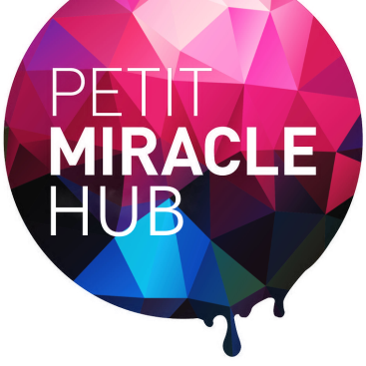

New enterprise at West 12 is far from petit

Pop-up retailers have taken over kiosks in shopping centre
A new and exciting way of shopping, bringing local and independent entrepreneurs closer to London shoppers, has arrived in Shepherd’s Bush.
The Petit Miracles Hub, an incubator for business owners from Hammersmith and Fulham, opened at West 12 shopping centre on 4 December (Thursday), providing a communal space for 20 emerging businesses.
Located on the first floor of the shopping centre, the Hub has welcomed business owners who have set up shop at specially designed kiosks, offering products ranging from candles, chocolates and cushions to fashion and jewellery.
Patrizia Galeota, Founder and Director of SensiChic Limited, who has rented a kiosk at the Hub, said: “It’s always been an ambition of mine to run my own business and I needed to change my work/life balance after the birth of my son. I wanted to develop something I could do from home and that would generate an income as well as offering the flexibility I needed as a mother.
“The Petit Miracles Hub is such an incredible initiative that will give entrepreneurs like myself an important stepping stone into retail; there really should be more projects like this up and down the country.”
The Hub provides a new shopping experience for visitors to West 12, where they can browse beautifully created items and speak to the people with the ideas behind them.
Totalling 6,000 sq ft, The Hub is the brain-child of the West 12 management team and Elisicia Moore, a passionate social entrepreneur and a self-confessed upcycling enthusiast who already owns the Hub’s sister store located at West 12, Petit Miracles Interiors.
It will house innovative meeting areas including a garden shed and presentation areas, as well as a DJ booth and café.

Elisicia Moore, Director of Petit Miracles, said: “The Hub will provide a great opportunity for people looking to trial a business or take it to the next level. We are so passionate about creating a fun and inspirational space where people can learn and succeed independently while being able to learn skills and different approaches from others around them.

“The rates are significantly lower than normal high street business rates. This was important as often these high rates are prohibiting amazing entrepreneurs from taking their first step onto the business ladder. The Hub will get people and their great services and products in front of shoppers in a cost effective way.”
The 20 available spaces, which have already been snapped up, are offered first to early-stage entrepreneurs based in Hammersmith and Fulham who either have a registered company or are soon to register.
Carl Meale, Centre Manager of West 12, said: “We are proud to have worked in conjunction with Petit Miracles to create such a pioneering concept. The Hub is a fantastic platform for showcasing local entrepreneurship. Not only will it introduce fresh, local talent into the retail industry via the business incubation model but The Hub will be a new creative centre for West 12 and Shepherds Bush.”
To find out more about the Hub, or to become a member, visit: http://www.petitmiracles.org.uk/hub

ENDS

For further information:
Website: http://www.petitmiracles.org.uk/hub info@petitmiracles.org.uk
Elisicia Moore, CEO and Founder Petit Miracles +44 7903566429

